Topic: Denial of Service attacks

Name: Prajeet Sridhar
Student ID: 105338683
Criteria 1: Planning and Justification

Threat Case Study
In the modern era, people are increasingly dependent on technology, which is utilized for online shopping, sending or storing confidential details, communicating with people, and traveling to places. Due to people being so reliant on technology, attackers find loopholes to steal people’s sensitive information. Attackers gain unauthorized access to an individual’s information by spreading viruses and using other attacking methods. One of the Attacking methods that hackers use is a DDOS attack. A DDOS attack, also known as a distributed denial of service attack, is a malicious cyberattack that sends a huge volume of internet traffic to a single target from multiple computers. The first DDoS attack that was first officially recognized and widely publicized happened in the early 2000s by a young boy named Michael, who triggered a huge DDoS attack against big firms like CNN, Yahoo, Amazon, Dell, eBay, and FIFA. DDoS has become a more major threat due to the rise of the Internet of Things. The Internet of Things is smart home devices like security cameras, smart TVs, and sensors connected through an internet connection. Nowadays, it's easier for hackers to stimulate DDoS attacks as they can send large amounts of internet traffic to unprotect Wi-Fi connections and exploit hardware or software vulnerabilities to gain access to IoT devices. The topic I have selected to work on is DDoS attacks, my project will go over the defending and attacking tools used to stimulate and mitigate DDoS attacks.

Types of DDOS attacks?

ICMP flood attacks: A ICMP flood attack is a type of Denial-of-service attack that attempts to flood a device with ICMP echo-requested packets, making the device inaccessible to network traffic.

SYN flood attacks: A SYN flood attack, also known as a half-open attack, is a type of DDoS attack that aims to disrupt the server by making it unable to respond to real traffic through consuming all its resources. The attacker does this by continuously sending SYN packets till they can overwhelm all the available ports on a targeted server.

UDP flood attacks: A UDP flood is a denial-of-service attack that sends UDP packets to disrupt the server functionality to process and respond to the attacks.

HTTP flood attacks: An HTTP flood attack is a type of volumetric DDOS attack that aims to send HTTP packets until the server becomes unresponsive.

DNS flood attacks: DNS(Domain Name System) flood attack is a type of DDoS where an attacker attempts to target one or more DNS servers within a specific zone to disrupt the resources in the zone.

Attacking and defending tool

The attacking tool and defending tool I have selected are Sudo Hping3 and iptables. Sudo Hping3 is an attacking network tool used to send ICMP packets, SYN packets, TCP packets, and UDP packets. Furthermore, it's easier for Wireshark to monitor the number of SYN, ICMP, TCP, and UDP packets being sent by the attacker. In addition, it is also a safe attacking tool used for testing, as it ensures that the packets being sent wouldn’t cause any damage to both the victim and the attacker VMS. It is also an easier tool for inexperienced hackers to use to stimulate SYN floods, ICMP floods, and UDP floods for testing purposes. The Hping3 attacking tool is a great tool for testing firewall behaviour like checking if a limited number of packets, how much packets are allowed to be sent to each port, and its ability to block any internet traffic. The limitations of using Hping 3, an attacking tool, are that it can’t be used to stimulate complex layer attacks like HTTP floods, can easily be blocked by firewalls or IDS/IPS systems, and requires root privileges for certain operations.

Snort is the defensive tool that I have selected to use in the Windows XP PRO virtual machine. Snort is an IDS defensive tool, is used to detect SYN packets and ICMP packets from being sent or any unusual traffic in the network traffic. The limitation of using snort is that it can cause performance issues with the virtual machines, can’t block any traffic by default and can be complex to use. In the testing scenario mentioned below, I have used hping3 to simulate ICMP flooding and SYN flooding in Kali Linux. In Windows XP pro, I have decided to use Snort as the defensive tool to detect the number of SYN and ICMP packets being sent.

Proposed Testing Scenario
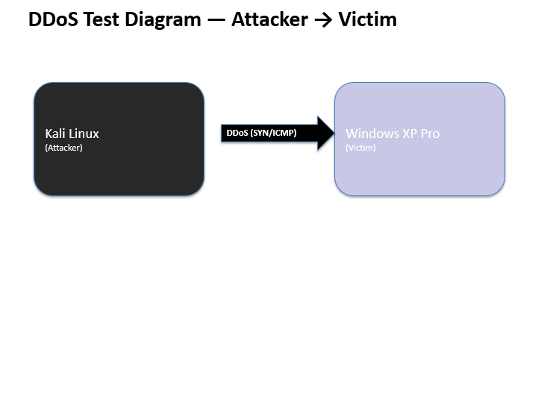
Steps
- Kali Linux acts as an Attacker and sends ICMP Packets and SYN Packets to the victim
- SYN and ICMP packets travel through the network to the Windows XP Pro
- Windows XP Pro receives the SYN and ICMP packets
- Snort in Windows XP Pro detects the number of SYN and ICMP packets being sent.

Mitre attacks TTPS

In the tested scenario mentioned above, I have stimulated DDoS attacks, ICMP flooding and SYN flooding. The SYN flood and ICMP flooding both link to network denial service (T1498) as they are both forms of DDoS attack. The SYN flood attack consumes the network TCP packets, preventing the server from responding to any legitimate traffic. The ICMP flooding slows down the server’s response to any valid traffic.

Metrics

Title | Overview | Key output to Observe | Classification
SYNFLOOD and ICMP Flood Attack | The Sudo Hping3 attacking tool is used to send ICMP packets and SYN packets | Page saying Hping is in flood mode, and no replies will be shown | Attacker Win
Snort as the defending tool | Snort is a defending tool is being used to detect the amount of SYN and ICMP packets being sent | Page showing the amount of SYN packet and ICMP packet being sent | Defender Win

What are other attacking tools that can be used for project?

LOIC: LOIC also known as low orbit Ion cannon, is a network stress testing and attacking tool used to flood networks and websites with network traffic. LOIC performs a DDOS attack by flooding the victim pc with TCP, UDP or HTTP requests. LOIC attacking tool is commonly used to identify any weakness on the website or network, deny the user from accessing any sensitive data, and it can also mimic a volunteer botnet when the network is used by multiple people. The limitations of using LOIC is that it requires multiple people and multiple computers to produce an effective DDoS attack and it can be easily detected by firewalls and IDS.

Metasploit: Metasploit is a penetration testing framework that is used to stimulate DDoS attacks through exploiting weaknesses in the network, systems, and application. It also allows attackers to modify the payload, making it a lot easier for the attackers to perform additional attacks.
The limitation of using Metasloit is that it is difficult tool to use for hackers to use as it requires a lot of technical knowledge and is not designed to send high volumes of DDoS attacks

Slowloris: Slowloris is an application layer DDoS attack tool that allows an attacker to exploit web servers by modifying the way the system manages HTTP connections. Slowloris sends partial http requests instead of sending a huge number of packets like other attacking tools. Slowloris send a partial HTTP request to keep the servers open as long as possible to prevent authorized users from accessing data in the system. The limitations of using Slowloris is that only targets application layered http servers, relies only on keeping connections slowly and can easily be mitigated with connection limits.

Nping: Nping is an attacking tool which is commonly used for flooding attacks and spoofing packets. Nping attack tool can be used to stimulate DDoS attacks as it can send unlimited amount of TCP, UDP and ICMP packets causing the network to be overwhelmed and dysfunctional. Nping allows attackers to spoof packets as they can manually change their source IP address allowing them to send DDoS attacks to the targeted pc while hiding their identity. The limitations of using Nping is that it can be easily detected using a firewall if the unusual network traffic is extremely high, and is mainly used for testing purposes.

Criteria 2: Application and Documentation

Deployment
<final deployment image>
Step 1: Use ifconfig command to check the address and netmask. This command can only be used for Linux virtual machines.
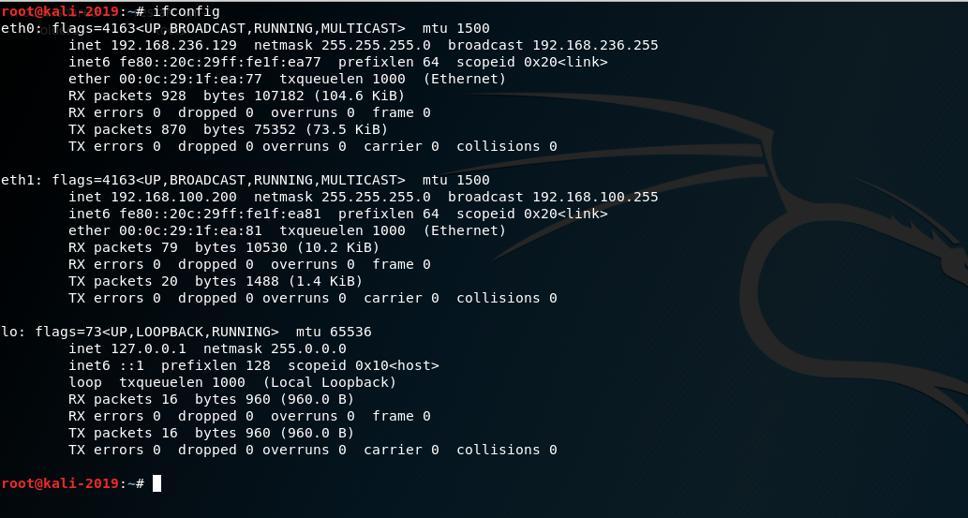
Figure 1 The image shows Kali virtual machine addresses for eth0, eth1 and lo

Step 2: Use the ipconfig command to check the subnet and ip address configured in the Windows XP Pro virtual machine
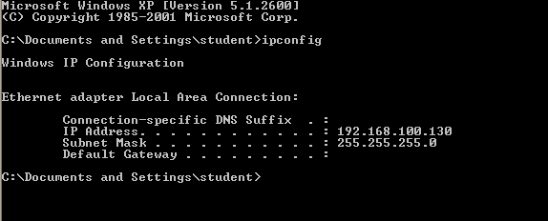
Figure 2 windows XPRO Ip address and subnet mask

Step 3: Use the ping command to check the connectivity of the addresses

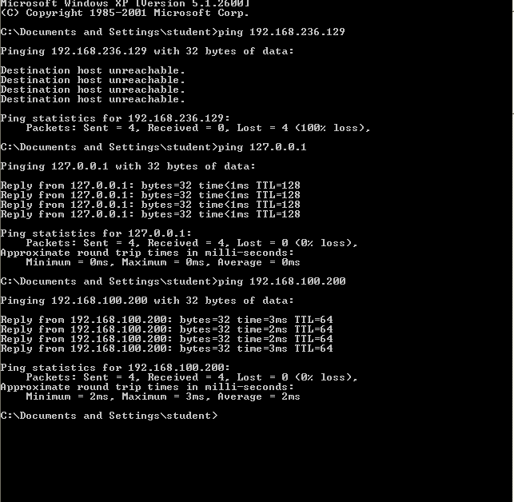
Figure 3 Ip addresses of kali virtual machine being pinged from Windows Xpro. The results shows that windows XPRO isn’t able to ping eth0. However, its able to ping ethl and loopback 0 addresses.

Deployment considerations
Before deploying the synflood and icmp first I needed to make sure that the packet is being sent to the correct address. I used the command ipconfig on the windows xpro to check the address and the subnet mask and I also used ifconfig on kali linux to check the ip address. Even though this isn’t a required step I also wanted to check the connectivity of the addresses before stimulating the DDoS attack.

Activity- Hping3 attacking tool
Step 4: Use Sudo Hping3 to send SYN packets
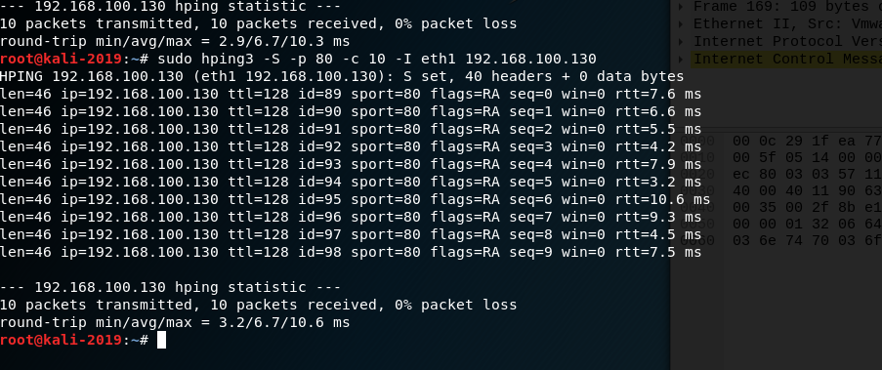
Figure 4: The image shows that Kali Linux has received 10 SYN packets

Step 5: Open Wireshark to check SYN flood packets
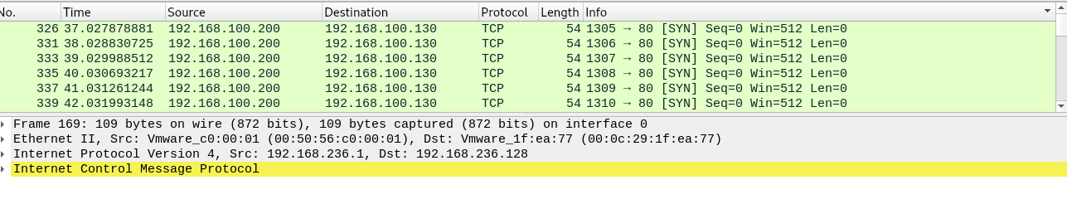
Figure 5 The images shows that syn packets have been successful sent because it is in tcp protocol and the info is SYN.

Step 6: Set the syn flood mode in Kali Linux

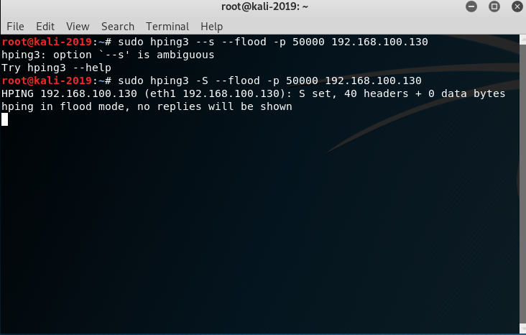
Figure 6 The image shows that Kali linux have been set to flood mode

Step 7: Open Wireshark to check the protocol and info of the SYN flood
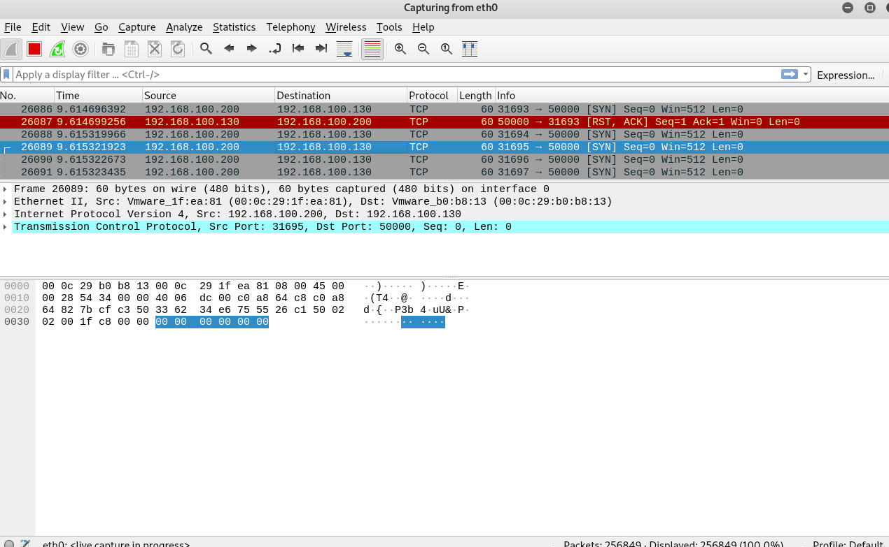
Figure 7 Wireshark displays the SYN packets and TCP protocols

Step 8: Set ICMP flooding on Kali Linux
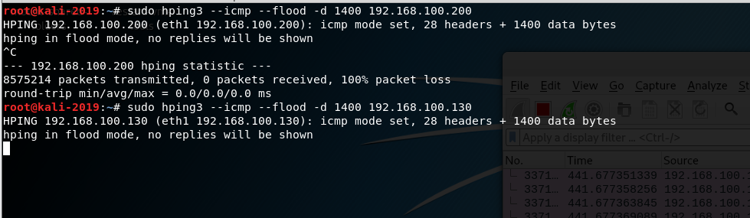
Figure 8 The image shows that ICMP flooding has been set using Sudo Hping3 attacking tool

Step 9: Open Wireshark to check the ICMP packets

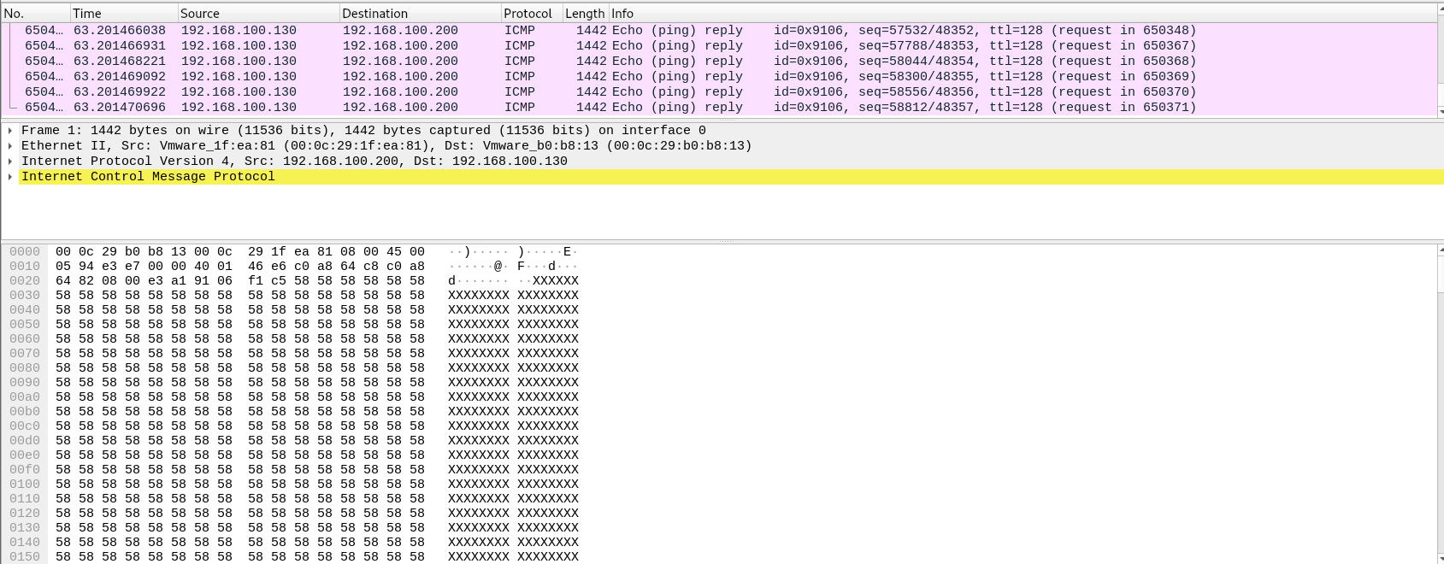
Figure 9 The image shows that the ICMP flooding was successful, as the protocol is in ICMP, and the Echo ping reply is in the info.
The images mentioned above I have used Wireshark to check the amount of SYN packets and the ICMP packets being sent. I have used the Sudo hping3 tool to stimulate ICMP and SYN floods in the Kali Linux.

Defending tool
As discussed in Criteria 1, Snort is the most effective defensive tool to use against DDoS attacks in Windows XP Pro. However, due it to is complexity and due to lack of updates in the Window XP Pro virtual machine I was unable to implement the Snort defending tool in Windows XP Pro. If my defending tool was running on Windows XP Pro it should be able to detect the unusual pattern caused by SYN flooding and ICMP flooding, it can detect what DDoS attack was being used by the attacker and provides details of metrics like traffic type, traffic volume, request rate of the packets and server response time. Another Defending that can be used in windows XP PRO is built-in firewall. Built-in firewalls are the default firewalls in a virtual machine. Built firewalls can block incoming traffic from an unknown user and it doesn’t use a lot of system resources. The limitations of using built firewalls are that it struggles to detect different type of DDoS attacks and can’t analyze traffic patterns. Overall, the best defensive tool is the snort defensive as it can detect SYN flooding and ICMP flooding, and any abnormality in the virtual machine.

Criteria 3: Analysis
Nowadays, it is easy to stimulate a DDoS attacks on a virtual machine. The attacker can now easily access data and tools to start DDoS attack. In Criteria 2 it is shown that anyone can run at DDoS attack on the virtual machine as it only takes one Sudo Hping3 attacking command to stimulate a simple DDOS flooding attack. The results indicate that an individual doesn’t have to have professional experience in the field to produce a simple DDoS attack. The challenges I have faced when doing this project is that I had issues with selecting the appropriate attacking tools and defending tools. Due to a lack of experience with using any tools in the virtual machines, I took me a while to decide which VMs should be the attacker and defender. Initially, I thought of using CYSCA2014INABox as the victim virtual machine, but I had issues with defending tools like Iptables in the system. I decided to select Windows XP Pro as the victim pc since it's not a Linux based virtual machine. I also had issues with stimulating the DDoS SYN flood and ICMP attacks, as I spent like 3 hours searching for the steps, I needed to take to stimulate DDOS attacks. I managed to solve this issue through watching multiple tutorial videos that go over simple steps for stimulating DDoS attacks. The results Criteria 2 indicate that I was successfully able to stimulate ICMP and SYN floods in the Kali Linux virtual machine as I was able to see the SYN and ICMP packets that were sent through using the Wireshark tool. When stimulating the ICMP floods and SYN floods, I always cleared my previous testing in the virtual machine and Wireshark to ensure that I could accurately check if my results were correct. To avoid any risks of accidentally corrupting my laptop, I have saved all my Virtual machines on a separate hard disk, and I have constantly taken screenshots of my results, copying to a USB to ensure that my results aren’t lost during a disaster.

An attacker can now uses attacking tools like Hping3, LOIC, HOIC, Metasploit Auxiliary and siege to stimulate DDoS attacks. As mentioned in criteria 2, there are issues with implementing defensive tools like Snort and other built-in firewalls in a Windows XP Pro virtual machine, indicating that these systems are highly vulnerable to DDoS attacks. To avoid these limitations that are mentioned in criteria 2 users must follow best practices like closing any unused ports, disabling any unnecessary services, constantly monitoring traffic, keeping up with the recent updates of the virtual machine, and having a disaster response strategy. Closing any unused ports helps with reducing the amount of traffic being sent making it harder for attackers to send any SYN flood or other DDoS attacks. Disabling unnecessary services prevents attackers from targeting any weak services in the system. Constantly monitoring traffic allows users to track and detect any abnormality in the system without the need of using defending tools like snort and IPS/IDS tools. Having a disaster response strategy allows individuals to prepare much quicker during an attack and allows them to isolate any infected systems without causing any issues to their database. Furthermore, constantly stay on track with the recent version of system will provide new security features and improves the performance of the system, preventing attackers from gaining any unauthorized access.

Criteria 4: Evaluation
Attackers have used a variety of attacking tools to stimulate different types of DDoS attacks to overload the website resources in the user’s system. Successful DDoS attacks can cause financial loss, downtime in the system, and data loss. The defenders can mitigate these attacks by using defensive tools and strategies like antivirus, network segmentation, traffic monitoring, and rate limiting. Network segmentation reduces the impact of the DDoS attack by dividing the network into smaller, isolated segments, preventing attackers from overwhelming the entire network with network traffic at once. For example, if the attacker floods one segment in the network, the other segments in the network will continue to operate normally, allowing time for the administrator to isolate the affected segments and to figure out the best method to mitigate the DDoS attack. Even though antiviruses don’t provide a direct solution, they can help mitigate DDoS attacks as they help prevent secondary attacks and prevent other infections that trigger DDoS attacks in the network system. Traffic monitoring may prevent DDoS attacks by constantly checking patterns of network traffic. The administrator will find it easier to identify if there is any unusual activity or abnormal packets being sent in the network. As a result, the administrator will have enough time to find the appropriate defending tool or defensive strategy to block any suspicious traffic. Rate limiting is a good defensive strategy, as it restricts the number of packets that are being sent to a single network, it restricts the attacker from sending a huge number of packets that flood the network, and it helps slow down massive attacks, allowing users to access and protect some of their data. Overall, the attacker aims to use the weakness of the system to their advantage while the defender focuses on eliminating any weakness in the network system. Following the essential 8 mitigation strategies, like application control, patch Applications, Configure Microsoft Office Macro settings, User Application Hardening, restrict administrative privileges, patch operating systems, multi-factor authentication, and regular backups will prevent DDoS attacks. Application Control will stop any unapproved DDoS tools like hping3, LOIC from running inside the network, and it also prevents other authorized users from using infected computers to attack another person’s website. Restricting administrative privileges will limit the impact of DDoS attacks as the unauthorized users will find it difficult to install DDoS attacking tools, making it difficult for them to reconfigure the system requirements in the network. This ensures that only the administrators can access and change the critical systems. Multi factor Authentication will protect admin and user accounts that are used to launch DDoS attacks inside the network as users will receive an authentication code when login into system to their email or authenticator app to ensure that the trusted user is accessing the network. As, this prevents unauthorized users from accessing the network using stolen passwords. Regular backups of data don’t prevent DDoS attacks; however, it allows you to recover data if the systems get corrupted by an attack. Patch Applications are mainly used to fix any security vulnerabilities in applications like web browsers, office software, and email clients. Patch applications can be used to prevent DDoS attacks by preventing attackers from using any weakness in the system to install DDoS bots. Patch Operating Systems can help prevent DDoS attacks by installing updates or security fixes that stop attackers from taking control of the network and adding to a botnet. For example, if a Windows server hasn’t installed its latest security patches, the attacker could identify and use the weakness to install malware or any other viruses. Then it can make the server part of a botnet, allowing it to launch ICMP floods, SYN floods, and other DDoS Attacks. Patching the network to the latest security patches will eliminate the weakness in the system, making it hard for attackers to launch a DDoS attack. Microsoft Office Macros are small programs inside office documents like Word or Excel, used to automate tasks and add other functionalities. Configuring Microsoft Office Macros can indirectly help with mitigating DDoS attacks by stopping malware from being installed through documents. Furthermore, Microsoft Office Macros help with disabling any infected macros and restricting them to users and administrators, preventing the risks of the systems being flooded by DDoS attacks. It also ensures that the network is secure, limiting the chances of it being involved in botnet activity.

References
[1]“History of Distributed Denial of Service Attacks | StormWall,” Cybersecurity Research, News and Insights | StormWall Blog, Nov. 06, 2024. https://stormwall.network/resources/blog/ddos-history
‌
[1] Rick Davis, “The History and Future of DDoS Attacks,” Cybersecurity Magazine, Jan. 15, 2021. https://cybersecurity-magazine.com/the-history-and-future-of-ddos-attacks/
‌

[1]“DDoS Attacks and the Internet of Things | DDoS-Guard,” DDoS-GUARD, Nov. 14, 2023. https://ddos-guard.net/blog/ddos-attacks-and-the-internet-of-things
‌
[1] Kali, “hping3 | Kali Linux Tools,” Kali Linux, May 23, 2024. https://www.kali.org/tools/hping3/
‌
[1]admin, “HPING3 in Kali Linux,” TestingDocs, Mar. 08, 2020. https://www.testingdocs.com/hping3-in-kali-linux/?utm_source (accessed Sep. 18, 2025).
‌

[1]Rohan Timalsina, “Linux Firewall: Configuration, Tools, Best Practices & More,” TuxCare, Feb. 10, 2025. https://tuxcare.com/blog/linux-firewalls/
‌

[1]“Review: Windows XP’s Built-in Firewall -- Redmondmag.com,” Redmondmag, 2025. https://redmondmag.com/articles/2001/09/24/review-windows-xps-builtin-firewall.aspx (accessed Sep. 18, 2025).
‌
[1] Cloudflare, “How to prevent DDoS attacks | Methods and tools,” Cloudflare.com. https://www.cloudflare.com/learning/ddos/how-to-prevent-ddos-attacks/
‌
[1] A. Bright, “The Role of Network Segmentation in Preventing Cyber Attacks -,” OutsourceITsecurity.com, Feb. 25, 2025. https://outsourceitsecurity.com/the-role-of-network-segmentation-in-preventing-cyber-attacks
‌
[1] “Introduction to macros - Microsoft Support,” Microsoft.com, 2024. https://support.microsoft.com/en-au/office/introduction-to-macros-a39c2a26-e745-4957-8d06-89e0b435aac3
‌

[1] Imperva, “What Is Metasploit | Tools & Components Explained | Imperva,” Learning Center, 2024. https://www.imperva.com/learn/application-security/metasploit/
‌
[1] “Essential Eight explained | Cyber.gov.au,” Cyber.gov.au, 2017. https://www.cyber.gov.au/business-government/asds-cyber-security-frameworks/essential-eight/essential-eight-explained
‌

[1] Cloudflare, “Slowloris DDoS Attack | Cloudflare,” Cloudflare. Available: https://www.cloudflare.com/learning/ddos/ddos-attack-tools/slowloris/
‌
[1] “Nping - Network packet generation tool / ping utiliy,” nmap.org. https://nmap.org/nping/

‌[1] Imperva, “What is LOIC - Low Orbit Ion Cannon | DDoS Tools | Imperva,” Learning Center. https://www.imperva.com/learn/ddos/low-orbit-ion-cannon/
‌

